April 23
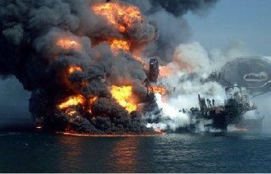Deepwater Horizons 5th Anniversary Panel Discussion
On April 20, 2010, a blow out of a deep-sea oil rig operated by British Petroleum spewed nearly 5 million barrels of crude oil into the Northern Gulf of Mexico before it was finally capped three months later. Five years on, exactly what impact has this all-time worst oil spill in history had on fish and other marine wildlife and coastal ecosystems throughout the Gulf? Four expert marine scientists in diverse fields will provide the best answers to this key question.
Doors Open at 6:00pm – Presentation Starts at 7:00pm
Challenger Learning Center – 200 South Duval Street, Kleman Plaza
Member Price: $8 Non-member Price: $15

