CHAPTER 12 Food, Soil, and Pest Management

Core Case Study: Golden Rice: Grain of Hope or an Illusion?
- Poor children that lack Vitamin _____ are likely to go blind and are susceptible to common infectious diseases.
- In 1999, how did scientists, Potrykus and Beyer, help solve this problem?

12-1: What is Food Security and Why Is It Difficult to Attain?
Is there enough food in the world for everyone to have food security? _______
What is the root cause of food insecurity?

Macronutrient | Food Source | Function/Importance

Micronutrients include ____________________ & ______________________
Consequences of undernutrition include
1. ____________________________________________
2. ____________________________________________
3. ____________________________________________
Complications from malnutrition
Iron: ________________________________________________________________
Vitamin A: ___________________________________________________________
Iodine: ______________________________________________________________
Famine (crop failures) occur from
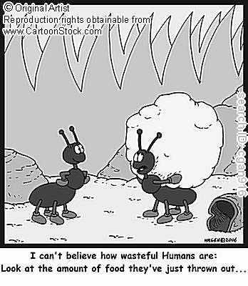
1. ____________________________________________
2. ____________________________________________
3. ____________________________________________
4. ____________________________________________
Consequences of Overnutrition
1. ____________________________________________
2. ____________________________________________
3. ____________________________________________

_____ billion people are sick because they do not eat enough,
_____ billion people are sick because they eat too much.
Annual Costs:
Money spent annually by Americans on weight loss: ____________
Projected cost to eradicate world hunger: ___________

12-2: How Is Food Produced?
Three systems produce most of our food
1. ________________________________________ ( %)
2. ________________________________________ ( %)
3. ________________________________________ ( %)
The three main grains worldwide are ____________, ____________, & _____________.
Types of Agriculture:
- High Input (Industrialized) Agriculture
Uses ________________
Requires inputs of: ____________________, ___________________, ____________________, __________________ & _________________.
Main goal is to:_______________________________________________
Forms of Industrialized Agriculture:
Plantation Agriculture | Greenhouses

- Low Input (Traditional) Agriculture
Subsistence Agriculture | Intensive Agriculture
Why is it a good idea for farmers to grow polycultures?

Slash and Burn agriculture involves ___________ and clearing small plots of land, growing a _____________ of crops for a few years until the soil is _______________, and then shift to another plot.
The Green Revolution
Goal: _________________________________________________________
3 Requirements:
1. ______________________________________________________
2. ______________________________________________________
3. ______________________________________________________
The Second Green Revolution

Grain production has __________________ due to the Green Revolution

Genetic Engineering:
Problems with traditional artificial selection
1. ______________________________________________________
2. ______________________________________________________
Benefits of genetically engineered crops – They are resistant to:

1.

2.

3.

4.

5.

6.

7.

Meat Consumption:
Livestock is raised in ______________ or ______________________________.
Meat production has increased ___________ between 1961 and 2007.
Demand for meat will increase as ________________________________.
This will require more ____________ for feed.

Fish and Shellfish Production:
Fishery-

Aquaculture-

Why is this sometimes called the blue revolution?

Uses ________________ as feed.
This could be a problem because
_________________________________________________________________.

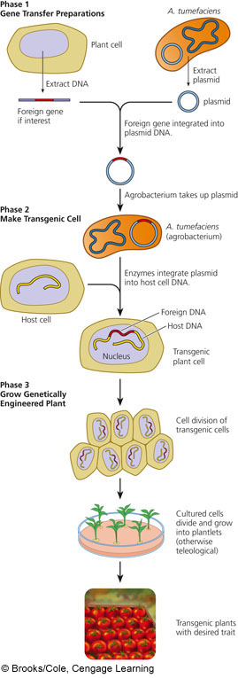

Soil: Some of this can be found on pg 281 in Science Focus. The rest you will get in class.
Topsoil provides:
1. _________________________________________________________________
2. _________________________________________________________________
3. _________________________________________________________________
4. _________________________________________________________________
Types of Weathering:
- Chemical Weathering
- _______________________________
  - __________________________________________________________
b. __________________________________________________________
c. __________________________________________________________
d. __________________________________________________________
3. Organic Weathering
What determines soil type? Typical Soil Make-Up
1. _________________________________ ____% Air
2. _________________________________ ____% Water
3. _________________________________ ____ % Mineral Matter
4. _________________________________ ____ % Organic Matter
5. _________________________________
a. ___________________________ What happens in the:
b. ___________________________ A layer?________________
c. ___________________________ B layer?________________
d. ___________________________

Define: Sketch and label a soil profile:
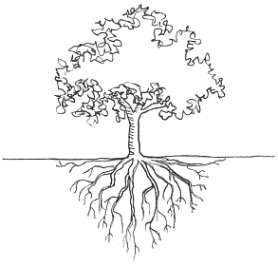
Soil Profile-

Soil Horizons-

O Horizon-

A Horizon-

B Horizon-
Soil Type | Texture | Permeability | Porosity
Sand
Silt
Clay

C Horizon-

Humus-

Porosity-

Permeability-

12-3: What Environmental Problems Arise From Food Production?
Using Figure 21-9, describe 5 major harmful environmental effects of food production.
Biodiversity Loss | Soil | Water | Air Pollution | Human Health

What is soil erosion and what causes it?

Two Major Harmful Effects of Soil Erosion:
1.__________________________________________________________________
2.__________________________________________________________________
What is desertification?

Problems with Irrigation:
Salinization | Waterlogging

Industrialized food production requires about _____% of commercial energy in the US.

Advantages | Genetically Engineered  Foods | Disadvantages

How does growing corn in the Midwest for ethanol production decrease production of
seafood in the Gulf of Mexico?

Industrialized Meat Production:
Advantages | Animal Feedlots | Disadvantages

What is done with all of the livestock’s manure in the US?
Producing more meat will increase pressure on the _________ and __________ supply.

Advantages | Aquaculture | Disadvantages

12-4: How Can We Protect Crops from Pests More Sustainably?
What are pests?

In what situations are pests actually a good thing?

Pesticides:
Insecticides | Herbicides | Fungicides | Rodenticides

Where did humans get the idea to use chemicals as pesticides?

First Generation Pesticides | Second Generation Pesticides

Broad Spectrum Agents | Narrow Spectrum Agents

Why is Rachel Carson an important figure in environmental history?

Advantages | Modern Synthetic Pesticides | Disadvantages

Who regulates the sale and use of pesticides under what Act?

Is FIFRA working?

Alternatives to using pesticides:
1.__________________________________________________________________
2.__________________________________________________________________
3.__________________________________________________________________
4.__________________________________________________________________
5.__________________________________________________________________
6.__________________________________________________________________
7.__________________________________________________________________
Describe the Integrated Pest Management (IPM) program.

12-5: How Can We Improve Food Security?
Governments use 3 main approaches to influence food production:
Control Prices | Provide Subsidies | Let marketplace decide
List 2 of the 6 programs focused on saving children from poverty that you think are most important:
1.__________________________________________________________________
2.__________________________________________________________________

12-6: How Can We Produce Food More Sustainably?
Define: Soil Conservation-

Methods farmers use to reduce soil erosion:
Terracing | Contour and Strip Planting | Alley Cropping | Windbreaks

______ of the US’s original topsoil is gone.
What happened during The Dust Bowl?

Define: Organic Fertilizers-

Animal Manure | Green Manure | Compost

Describe one way aquaculture can be practiced more sustainably.

Why is polyaquaculture a good idea?

Describe one way meat can be produced more efficiently and humanely.

Define: Organic Agriculture-

What must happen for crops to be certified as organic?

Even though organic farming produces 20% less product, how do organic farmers make up for this?

According to Figure 12-32, list 3 benefits to organic farming:
1.__________________________________________________________________
2.__________________________________________________________________
3.__________________________________________________________________

Why is buying locally grown food a good idea?

