https://itunes.apple.com/us/app/ap-environmental-science-review/id413888693?mt=8​

This app is $4.00, but provides 10 or so lessons on different topics and has 50 review questions per topic. Could be a great resource for the students for APES exam and unit exams.
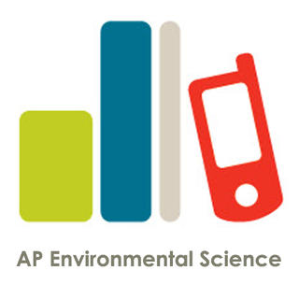 | AP Environmental Science Review on the App Store on iTunes  Read reviews, get customer ratings, see screenshots, and learn more about AP Environmental Science Review on the App Store. Download AP Environmental Science Review and enjoy it on your iPhone, iPad, and iPod touch.  Read more...

